Thank you for purchasing “Because Cockroaches Rule.” I have included 26 lesson plans that you are free to use anyway you wish. Change them to fit your grade level or adjust them to fit with your lesson plans. Look under the kids tab for a Louie the Roach coloring page.

If you make up your own lessons and want to share them with me, please email them to me at johnnyjroxx@gmail.com
I would love to share them with other educators.

If you are interested in an author visit by me and Louie the Roach (along with my other puppet friends) please email me. I am open to discuss any type of visit.
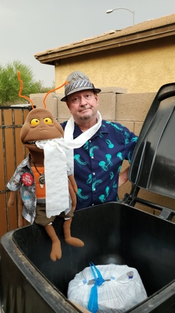
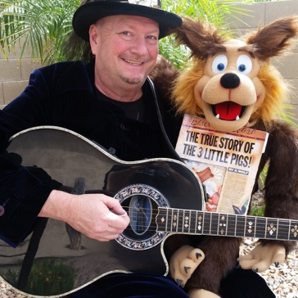

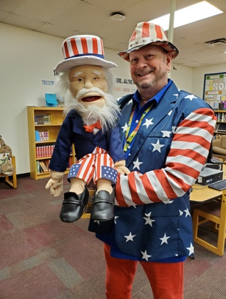
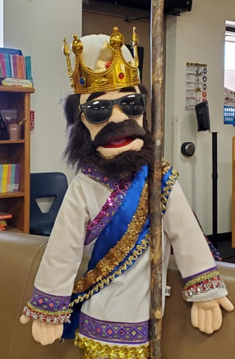

The Famous… KWL Chart!
Know, Wonder, Learned

Create a KWL chart before you read “Because Cockroaches Rule.”

- Write down what you know about cockroaches.

- What do you wonder about cockroaches? What questions do you have?

- What you have learned about the topic.

Once you are done reading the book, there may be an opportunity to further research your questions and find the answers if you didn’t find them in your reading.

“Because Cockroaches Rule”

www.johnjanezic.com

How Readers Develop Inferences

- Text Clues: Hints found in a sentence, paragraph, or passage that a reader can use to understand the meanings of new or unfamiliar words.

- Background Knowledge: The knowledge students have learned both formally in the classroom and informally through life experiences.

- Inference: An idea or conclusion that’s drawn from evidence based on text clues and background knowledge.

Background
Knowledge

Text Clues
Inference
+ =

It says… I know… I think….

“Because Cockroaches Rule”

www.johnjanezic.com
Louie The Roach Instagram Account

- Create an Instagram account, based on inferences, for Louie the Roach
- User Picture: Draw or paste an image of Louie above the word “Follow”
- Three Blank Boxes: Draw or paste images Louie would post and want to share (be prepared to orally explain why you choose the images)
- Instagram Username: Create a Username for Louie
- Profile Quote: Write a famous quote or song lyric that Louie might find inspirational
- ** Louie the Roach has a real Instagram account. Search Louietheroach to follow him

Follow

Instagram Username_________________________________________________

Profile Quote______________________________________________________
Follow Up Questions…

After you have read “Because Cockroaches Rule” think about the following questions. You may work by yourself, with a partner, or have a class discussion. Your teacher will tell you know what they prefer.

- Has the author tried to persuade you in anyway? How?

- Can you identify both the facts and opinions in the story?

- What new things have you learned?

- Were there any important illustrations and if so, why were they important?

- Did you have any unanswered questions, or did you want to research more information based on something you read?

“Because Cockroaches Rule”

www.johnjanezic.com
Making connections is the key for comprehension.
The three connections you can make with a book are:

- Text to Self
- Text to World
- Text to Text

Let’s explore the connections you made when reading “Because Cockroaches Rule.” Write them down and then share out.

- Text to Self: Share a story about yourself that is related to an event or a character in “Because Cockroaches Rule.”

- Text to World: Share a story, event, or character from “Because Cockroaches Rule” and compare them to the real world. Feel free to discuss the differences or similarities of what you see in the real world and what you read in the text.

- Text to Text: Based on the book “Because Cockroaches Rule” identify another story or film that is similar to the story you just read.

“Because Cockroaches Rule”

www.johnjanezic.com

Center Stage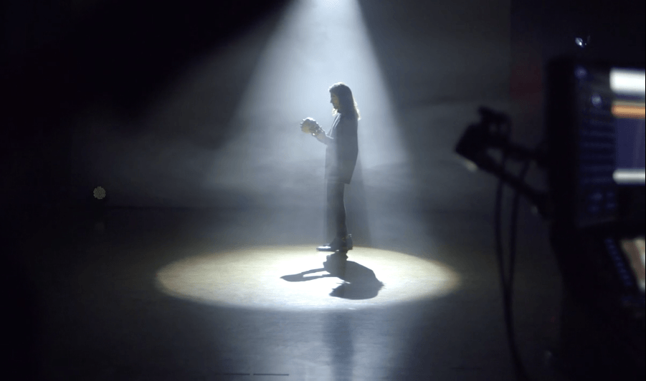

Put a chair in front of the class. Have someone come up and take a seat. This person will know become Louie the Roach. Anyone in the class can ask a question. The person in the chair must answer the question as they believe Louie the Roach would answer.

Example: Louie what is your favorite food? I like banana peels and glue. I also like to eat crumbs I find in the kitchen and sometimes cat litter that spilled out of the litter box.

“Because Cockroaches Rule”

www.johnjanezic.com

Three Wishes

A Genie (named Monti) lands in the book “Because Cockroaches Rule” and grants Louie the Roach three wishes!

What does Louie wish for and why?

Would Louie’s wishes have changed anything about the story?
If so, how?

“Because Cockroaches Rule”

www.johnjanezic.com

It is Louie the Roaches Perfect Day!

Plan his ideal day.
Where would he go?
What would he wear?
What would he eat?
Who would he hang out with?

Make sure you justify the answers to the questions in relation to what you read about Louie.

“Because Cockroaches Rule”

www.johnjanezic.com

