Thank you for purchasing “Because Cockroaches Rule.” I have included 26 lesson plans that you are free to use anyway you wish. Change them to fit your grade level or adjust them to fit with your lesson plans. Look under the kids tab for a Louie the Roach coloring page.

If you make up your own lessons and want to share them with me, please email them to me at johnnyjroxx@gmail.com
I would love to share them with other educators.

If you are interested in an author visit by me and Louie the Roach (along with my other puppet friends) please email me. I am open to discuss any type of visit.
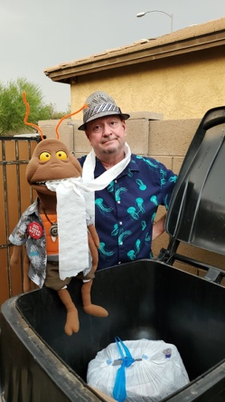

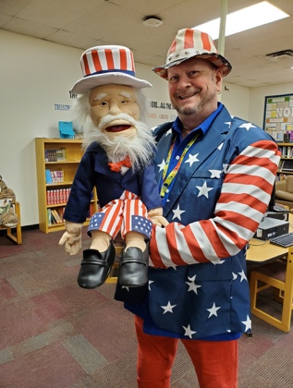
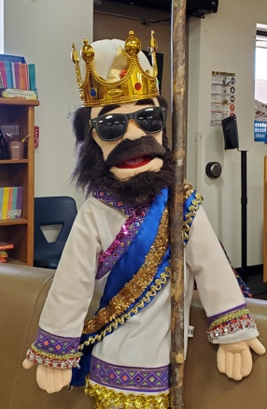

The Famous… KWL Chart!
Know, Wonder, Learned

Create a KWL chart before you read “Because Cockroaches Rule.”

- Write down what you know about cockroaches.

- What do you wonder about cockroaches? What questions do you have?

- What you have learned about the topic.

Once you are done reading the book, there may be an opportunity to further research your questions and find the answers if you didn’t find them in your reading.

“Because Cockroaches Rule”

www.johnjanezic.com

Tell A Friend…
Writing a Personal Letter
Write a personal letter to your friend or relative about the book “Because Cockroaches Rule.” Start with a couple sentences describing what the book is about then write what you particularly liked about the book. If there is something you disliked about the book, include that in your letter too. Mention your favorite part and tell why it was your favorite part. Write about connections you have with the book and if it reminds you of other books. In conclusion feel free to give it a rating. Have fun and come up with your own rating.
Example: Out of a total of 5 cockroaches, I give “Because Cockroaches Rule” 5 cockroaches.
Personal Letter
- Write your address on the top right-hand corner of the page: The person receiving your letter may want to write back but may not have your address.

- Salutation or Greeting: Say hello to the reader. Example: Hi, Hello, Greetings, or Dear. This type of letter begins with a casual greeting.

- Body: This part of the letter includes the information or news you wish to communicate.

- Closing and Signature: Saying good-bye to your friend or relative. Start with Love or Sincerely (make sure this is capitalized and followed by a comma) Directly beneath the closing, place your signature.

“Because Cockroaches Rule”
www.johnjanezic.com

From Me to You…

- Think of a gift you would like to give Louie the Roach
- Explain why you have chosen the gift for Louie
- Think of a gift that may help him, reward him for doing something nice or for just being a nice guy. Use context clues throughout the book to help you infer what gift Louie would like.

Tips to remember when writing:
- You can do it! Anyone can be a writer. Writers like to share their thoughts and experiences. Everyone has thoughts and experiences!
- Focus on your creativity and imagination. Don’t stress about spelling the words correctly. Get your ideas on paper and organize them later.
- Have fun.

“Because Cockroaches Rule”
www.johnjanezic.com

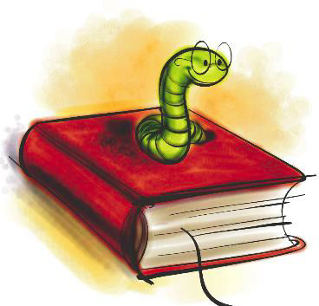
Book Blurb

A book blurb is a written description usually found on the back of the book. Book blurbs can also be found on the inside cover of a book.

A good book blurb will give the reader enough information to get us excited and interested about wanting to read the book. However, be careful not to give too much information away or spoiling the surprises for the reader.

Now it’s your turn to have some fun with book blurbs. Write a book blurb for “Because Cockroaches Rule.” If you need some ideas look at the book blurbs on the books in your classroom or school library.

Have fun…

“Because Cockroaches Rule”
www.johnjanezic.com
Advertisements

Create an advertisement poster for one of the two delicious recipe items found in the activity section of “Because Cockroaches Rule.”

Grandma Kakerlake’s German Potato Salad

Or

Grandpa Fritz’s German Chocolate Cake

Don’t forget to include all the tasty things that will go into it.

Make it as colorful and visually attractive as possible so that everyone will want to try the delicious German Potato Salad or the mouthwatering German Chocolate Cake.

“Because Cockroaches Rule”
www.johnjanezic.com

Storytelling…

After reading “Because Cockroaches Rule” you suddenly become obsessed with wanting to be a cockroach. You hear of a secret science lab that “has been rumored” to be conducting experiments that turn human beings into animals and insects.

After several months of research, talking with people, and your sheer determination, you finally meet up with the scientist who can make your dream a reality. Dr. Turdus Maximus. He successfully transforms you into a beautiful cockroach. You have many adventures, you eat, play, make friends, and hang out with your new roach friends. After a week of living the cockroach dream, Dr. Turdus Maximus transforms you back to your beautiful human self.

You are excited to share all that has happened to you on your cockroach adventure. You decide to write an article for a famous Science Magazine so you can tell the world of all the weird and wonderful adventures you had while you were a cockroach. Don’t forget, a picture is worth a thousand words. Feel free to include a drawing of you as a cockroach or something exciting that happened to you as a cockroach.
“Because Cockroaches Rule”
www.johnjanezic.com

Louie The Roach is having a birthday party! He wants you to design his special birthday invitations. Make sure to include these items in your invitations:

- Date
- Time
- Location
- Theme of the party

Make the invitation colorful and exciting. Feel free to use colored paper or draw your own designs.

“Because Cockroaches Rule”
www.johnjanezic.com
Don’t Judge a Book by its Cover

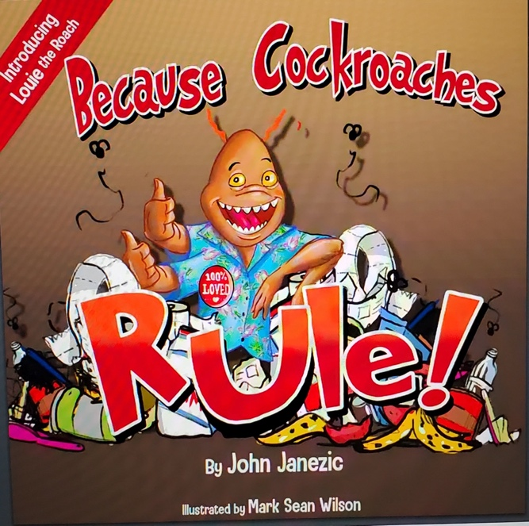

You may have heard the statement before “Don’t Judge a Book by its Cover” however the cover is probably the most important part in making it stand out from the crowd in a library or bookstore.

Today, your task is to come up with a new book cover for “Because Cockroaches Rule.” Make sure it is visually appealing and contains eye-catching images. Every book cover must contain the name of the author and the title of the book. Be creative. Have fun. Make sure you share them all when you are done and explain why you made the cover the way you did.

Think about the facts you just read in the book and feel free to use any of them as your cover inspiration.

“Because Cockroaches Rule”

www.johnjanezic.com
Bookmarks

Design your very own bookmark for “Because Cockroaches Rule.”

Make sure to include the following items on your bookmark:

- Title of book
- Author
- Tagline: A tagline is something that will hook potential readers and make them want to read the book.

Here are some tips in writing a tagline:
- Keep it short. A tagline is usually just one line. ...
- Capture tone. Is your book funny? ...
- Pique interest. ...
- Keep it fresh. ...
“Because Cockroaches Rule”

www.johnjanezic.com

Dear Diary…

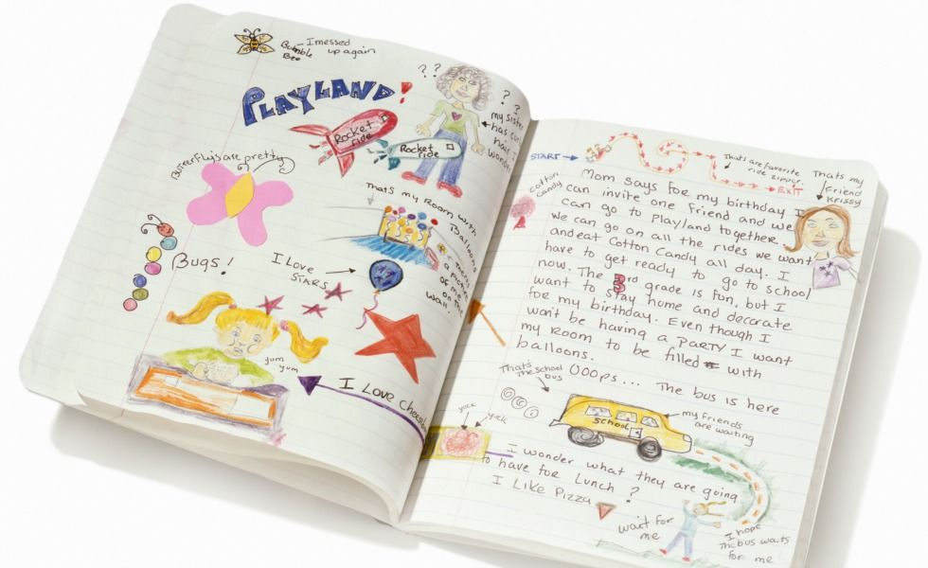

Diary: a book in which one keeps a daily record of events and experiences.

Place yourself in the shoes of Louie the Roach. You will create a diary entry for Louie’s day. Remember you will write as Louie. Tell us about what your day was like. Remember to think about the information you learned in the book.

When you are writing a diary entry, you are writing it from first person perspective.

“Because Cockroaches Rule”

www.johnjanezic.com

Write a Different Ending

Fun Fact: When a film is made the director usually films a few different endings so they can determine later which one to release after a test audience gives them feedback.

Could there be a better ending to “Because Cockroaches Rule?” Here is your chance to change the ending of the story and go in a different direction from what the original author had intended.

Be creative and have fun. Don’t forget to share your story with someone else who has read the same book.

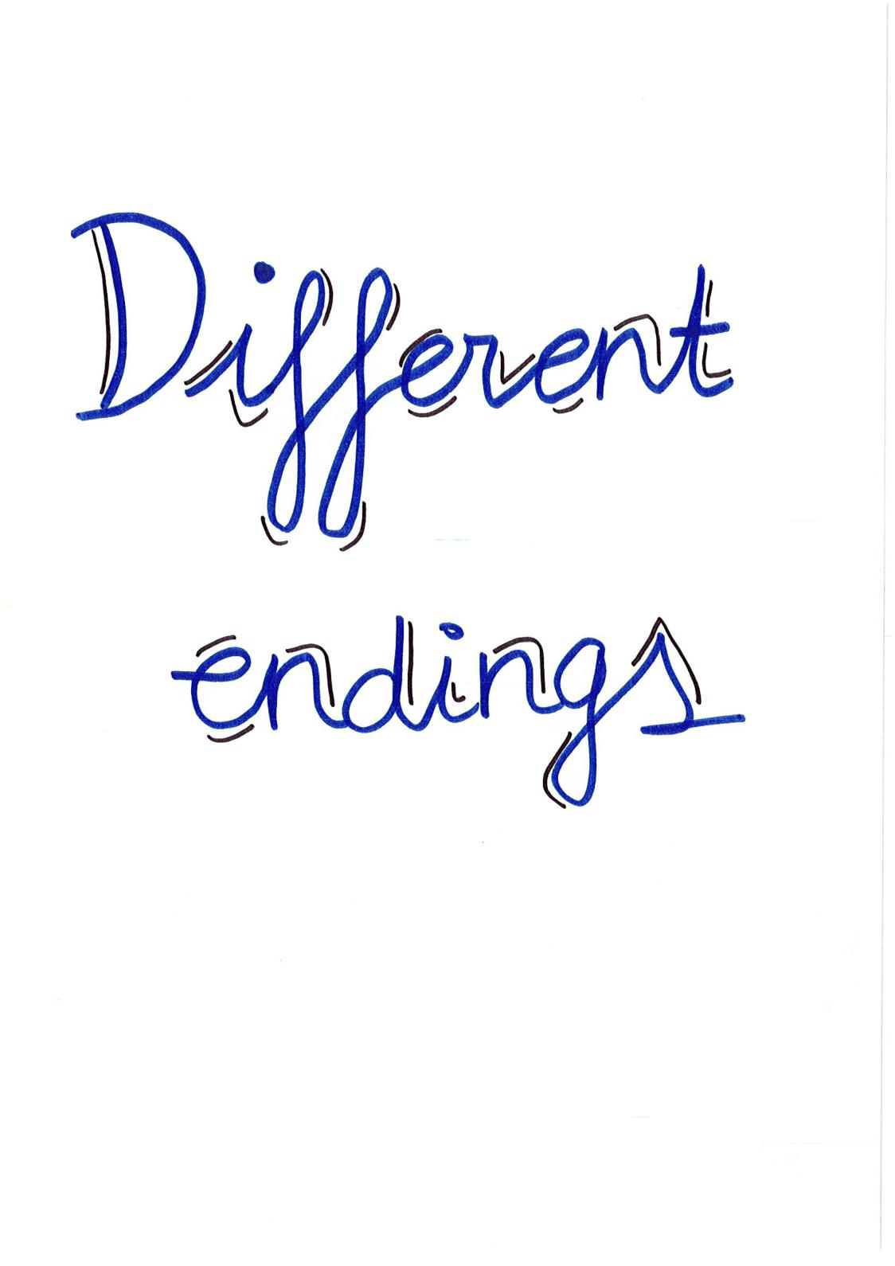

“Because Cockroaches Rule”

www.johnjanezic.com

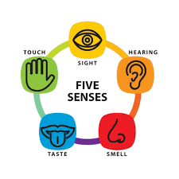

For each of the five senses, list the most memorable ones from “Because Cockroaches Rule.” The most memorable things Louie the Roach heard, saw, touched, smelled, and tasted.

“Because Cockroaches Rule”

www.johnjanezic.com

Page by Page

You will condense each page of “Because Cockroaches Rule” to a single sentence and then draw an image to represent each page. Do one for every page.

The toughest part of this task will be to condense the information into a single sentence!

*Hint…
Use the image you draw to tell us a little more information.

“Because Cockroaches Rule”

www.johnjanezic.com

What would be a great job for Louie the Roach? Choose a job for Louie! You can choose a made-up job that is really funny like a security guard for Spiderman or something more realistic like a chef in a fancy restaurant.

Be creative, have fun, just be sure to write down the job you chose and why you chose that job.

“Because Cockroaches Rule”

www.johnjanezic.com

QUIZ SHOW

Make up five quiz show questions you could ask someone about “Because Cockroaches Rule.”

Make sure the answers can be checked in the book if necessary.
“Because Cockroaches Rule”

www.johnjanezic.com

Look for an important object or item from “Because Cockroaches Rule” and create an advertisement for it on eBay. If you are not sure what eBay is, feel free to just create the ad and share it in the classroom.

Make sure to include a picture, it’s strongest selling points, and try to make us buy it by using persuasive language.

“Because Cockroaches Rule”

www.johnjanezic.com

Game Designer

You have been asked to turn Louie the Roach into a video game! On a piece of paper provide some sketches of Louie and objects you might find in your video game.

Questions to answer:
What type of game will this be?

What is the storyline or plot of the game?

Who is your audience? Think of ages. Older or younger.

“Because Cockroaches Rule”

www.johnjanezic.com

Book Report

Title:

Author:

My favorite part in the book was…

Rating:

ccxxxxxxxxxxxxxxxxxxxxxxxxxxxxxxxxxxxxxxxxxxxx

Ccccccccccccccccccccc

My overall opinion of the book is…

ccxxxxxxxxxxxxxxxxxxxxxxxxxxxxxxxxxxxxxxxxxxxx

Ccccccccccccccccccccc

