Would You Ever Kiss a Cockroach?

By: John Janezic

Free Lesson Plans

1. The Oldest Candy
- Research Prompt: Find out what the very first manufactured candy was. (Hint: It was probably made with honey and dates back to the ancient Egyptians!)
- Activity Idea: Kitchen Chemistry: Make simple rock candy by dissolving a lot of sugar in hot water. Discuss the difference between a liquid and a crystal.
- Math Connection: If ancient people traded candy for other goods, what might one piece of candy have been worth?

🐸 2. Something About Frogs
- Research Prompt: What is the life cycle of a frog? Look up the difference between a frog and a toad.
- Activity Idea: Habitat Hunt: If safe, go on a nature walk. Try to find a pond or damp area. Discuss why frogs are considered an indicator species (a sign of a healthy environment).
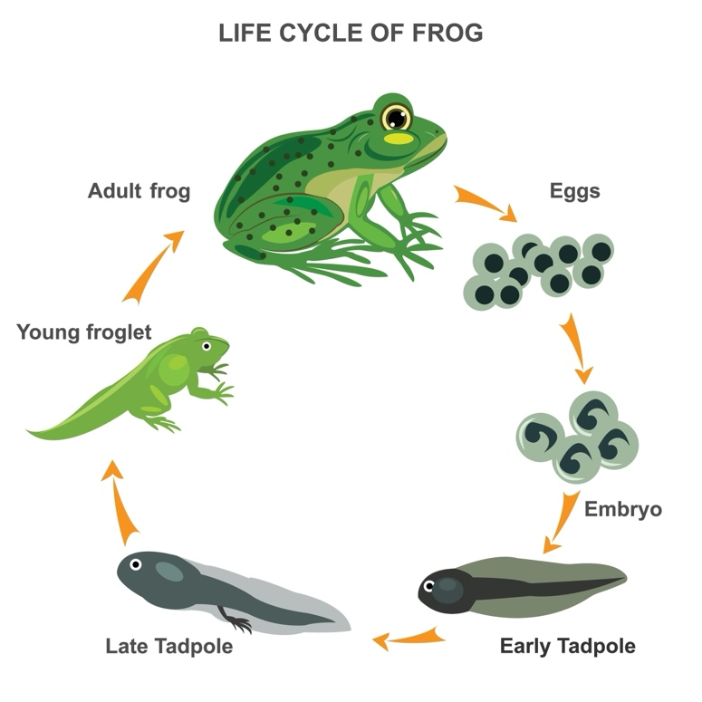
- Science Focus: Discuss how a frog's long, sticky tongue works to catch fast-moving insects.

🧜‍♀️ 3. Mermaids
- Research Prompt: Mermaids and similar creatures appear in stories from all over the world (e.g., the Greek Sirens or the Irish Merrows). Research a mermaid story from a culture different from your own.
- Activity Idea: Ocean Creatures: Mermaids often live with real sea animals. Research a fascinating deep-sea creature (like the anglerfish or the giant squid).
- Creative Writing: What would a mermaid eat for dinner? Write a fun menu based only on things found in the ocean.
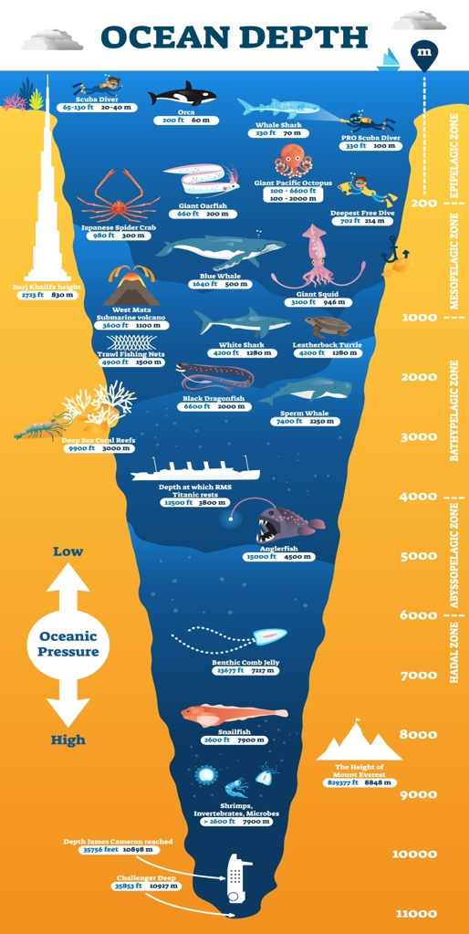

🐜 4. Ant Strength
- Research Prompt: How much can an ant really lift compared to its own body weight? Find out the record holder for the strongest insect!
- Activity Idea: Lifting Challenge: Have the child lift a paperclip, then a cotton ball, then a small toy. Discuss how much stronger the ant is because of its small size and exoskeleton.
- Vocabulary: Learn the words colony and foraging.

🍀 5. Leprechaun
- Research Prompt: Leprechauns come from Irish folklore. Where does their love of gold and shoemaking come from?
- Activity Idea: Design a Trap: Leprechauns are known for being clever. Design and draw a (harmless!) trap to try and catch a leprechaun, discussing simple machines like levers or ramps.
- Geography: Locate Ireland on a map and learn one fun fact about the country.

🐉 6. Dragons
- Research Prompt: Compare the dragons of Asian folklore (often wise and benevolent) with the dragons of European folklore (often greedy and fire-breathing).
- Activity Idea: Building Challenge: Dragons often guard treasure! Use pillows, blankets, or blocks to build a protective lair and hide a favorite toy inside.
- Science Focus: If dragons did breathe fire, what kind of gas or chemical reaction would be required?

👤 7. Giants
- Research Prompt: Giants are in many stories (like Jack and the Beanstalk). Research the tallest person ever recorded in real life.
- Activity Idea: Measure Up! Use a tape measure or ruler to measure your child’s height and compare it to the height of an average adult. If a giant was ten times as tall as you, how tall would they be?
- Art Project: Draw a picture of a giant and try to make the background objects (trees, houses, people) look correctly small next to him.

🐄 8. Cows, Ice Cream
- Research Prompt: How is milk turned into butter and ice cream? Where did ice cream first become popular?
- Activity Idea: Make Your Own! Search for a simple recipe for making ice cream in a baggie using ice and salt. (The salt makes the ice colder!)
- Science Focus: Discuss the three states of matter (solid, liquid, gas) in relation to milk, ice cream, and steam.

🪐 9. Planet Jupiter Gas Planet
- Research Prompt: Why is Jupiter called a Gas Giant? What is the Great Red Spot?
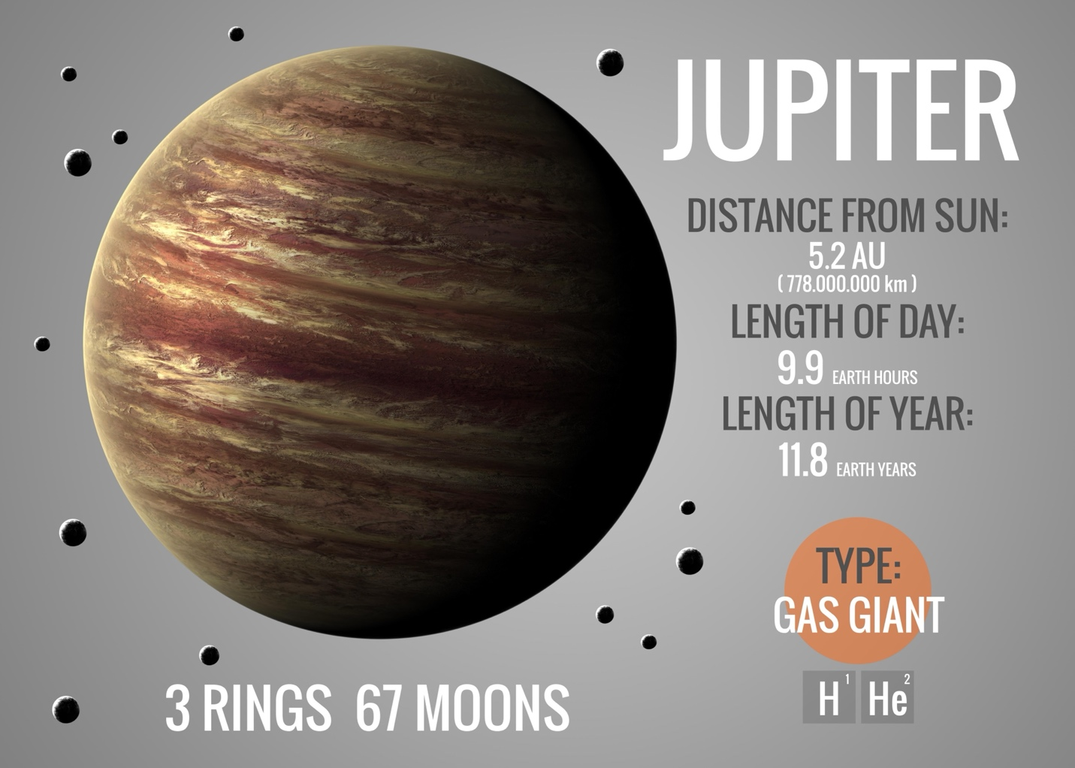

- Activity Idea: Jupiter Model: Use a balloon, paint, or playdough to create a model of Jupiter. Remember to include the bands of swirling gas and the Great Red Spot!
- Compare and Contrast: Research the difference between Jupiter (a Gas Giant) and Earth (a Terrestrial/Rock Planet). Discuss the extreme weather on Jupiter.

🏗️ Standards & Goals by Topic

1. The Oldest Candy & 8. Cows (Ice Cream)
Focus: Physical Science (States of Matter) & History.
- AZ Science Standard (2.P1U1.1): Plan and carry out an investigation to determine that matter has different properties and can change state.
- Target Goal: Students will observe a phase change (liquid to solid/crystal) and identify the role of temperature in that process.

2. Something About Frogs & 4. Ant Strength
Focus: Life Science & Adaptation.
- AZ Science Standard (3.L1U1.5): Develop and use models to explain that plants and animals have internal and external structures that serve various functions in growth, survival, and reproduction.
- Target Goal: Students will be able to explain how an "indicator species" (frogs) or an "exoskeleton" (ants) helps an organism survive in its specific environment.

3. Mermaids, 5. Leprechauns, & 6. Dragons
Focus: Folklore, Cultural Literacy, and Narrative Writing.
- AZ ELA Standard (4.RL.9): Compare and contrast the treatment of similar themes and topics (e.g., opposition of good and evil) and patterns of events (e.g., the quest) in stories, myths, and traditional literature from different cultures.
- Target Goal: Students will identify one cultural difference between two versions of the same mythical creature (e.g., Asian vs. European dragons).

7. Giants
Focus: Measurement and Ratios.
- AZ Math Standard (3.MD.B.4): Generate measurement data by measuring lengths using rulers marked with halves and fourths of an inch.
- Target Goal: Students will calculate "Giant Scale" by multiplying their own height by 10 and comparing it to the ceiling height of the library.

9. Planet Jupiter
Focus: Earth and Space Science.
- AZ Science Standard (6.E1U1.1): Analyze and interpret data to show that the Earth and its solar system are part of the Milky Way Galaxy.
- Target Goal: Students will differentiate between "Terrestrial" and "Gas Giant" planets based on composition and density.

